## Session 8 Assignment 1

Sample dataset:

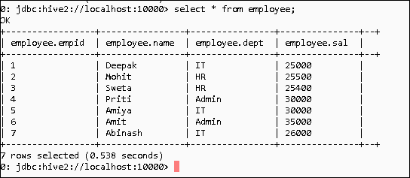

Task 1 –Get list of employees getting salary less than 100 as compared to other employees in their department having greater salary.

select a.empid,a.name,a.dept,a.sal AverageSalary from (select empid,name,dept,sal from employee) a join (select sal,dept from employee ) b on a.dept=b.dept where b.sal>a.sal and b.sal-a.sal=100;

Output:

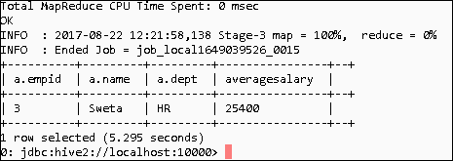

Task 2 – Get the list of employees having salary greater than the average salary of their department.

select a.empid,a.name,a.dept,a.sal,b.sal1 AverageSalary from (select empid,name,dept,sal from employee) a join (select dept,avg(sal) sal1 from employee group by dept) b on a.dept=b.dept where a.sal>b.sal1;

Output:

